Week two: MY STUDENT APP
App title: my student app
Background color : neon pink
Font-size:16-24
Purpose: An asynchronous campus API student profile app with local data fallbacks.
Login page
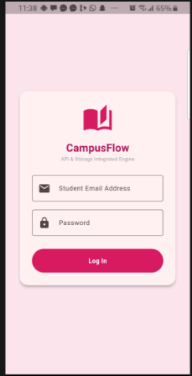

After signing in:

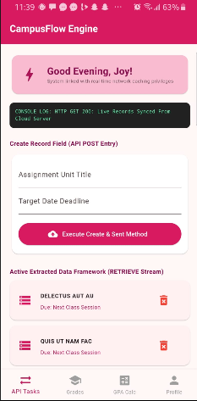
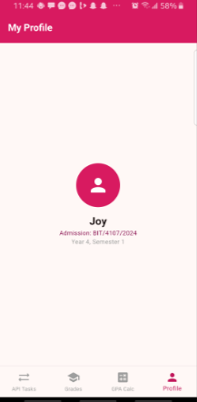

PERSONAL REFLECTION
Data integration is not just about code — it's about planning the data flow: where does data come from, where is it stored, how is it displayed, and how is it updated? Without this plan, the app becomes messy quickly.
WEEK 3: USER INTERFACE (UI) DEVELOPMENT
System giving alert on wrong email format
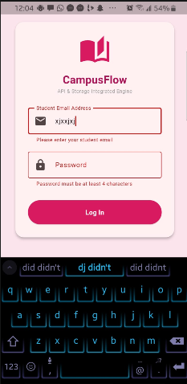

Dashboard screen

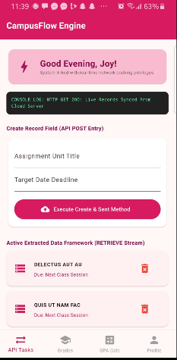

Functional academic transcript button

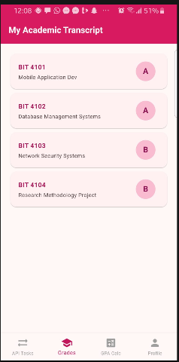

Functional grade calculator
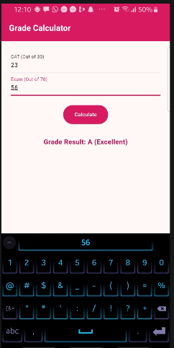
PERSONAL REFLECTION
Transitioning from abstract conceptual wireframes to structural front-end layouts was incredibly rewarding. I focused heavily on building a clean, modern, and perfectly balanced, gender-neutral interface, ensuring high readability for tracking critical academic data components effortlessly.

WEEK 4: DATA MANAGEMENT
Sign up page
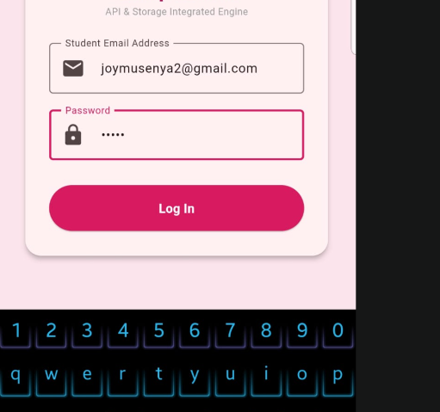

Add assignment
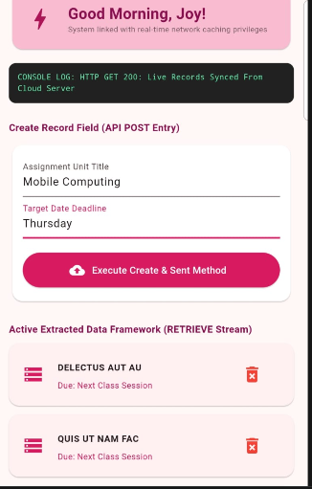

Dashboard after adding
